1. Use Linux 6.1.99 kernel version and add ath11k related drivers
2. Use
QCN9074/hw1.0/2.7.0.1/WLAN.HK.2.7.0.1-01744-QCAHKSWPL_SILICONZ-1 firmware version
3. Copy the firmware to the directory/lib/firmware/ath11k/QCN9074/hw1.0/directory, as shown in the following figure
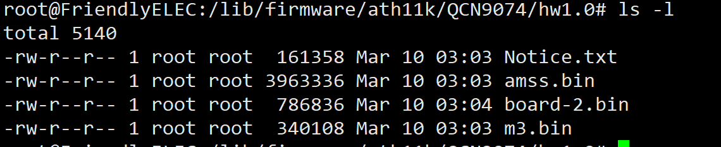
4. Load the ath11k driver successfully, and the kernel prints as follows.
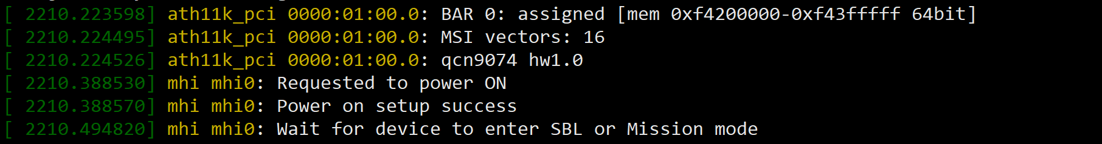
5. Use ifconfig to check that wlan0 has been recognized.
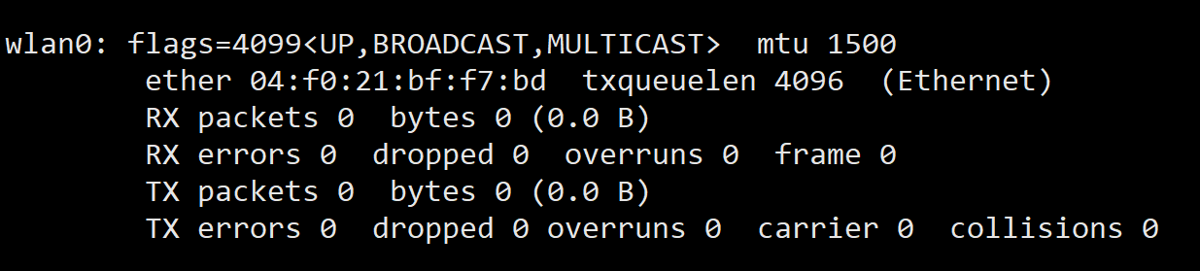
6.Scan external WiFi using the WPA_CLI scan and WPA_CLI scan_desult commands, only 5G band WiFi can be scanned
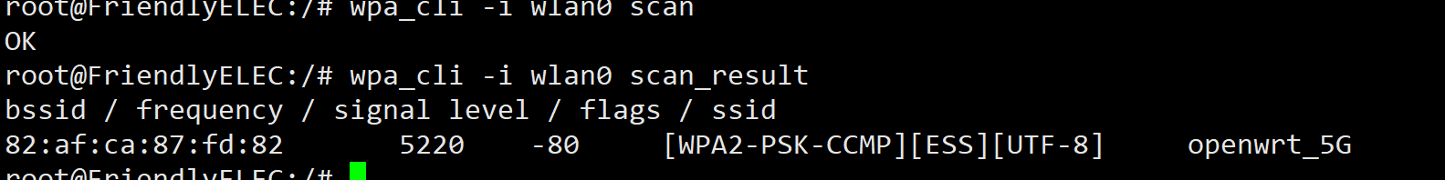
7.Connect to the scanned 5G frequency band WIFI for normal communication.

8. According to the previously provided document, replace the relevant firmware. The document content is as follows, please use serial console:
1.cd /lib/firmware
2.mkdir ath11k && cd ath11k
3.mkdir QCN9074 && cd QCN9074
4.mkdir hw1.0 && cd hw1.0
5.cp /directory/of/bdf.bin ./ (repeat this step for all above files)
6.ln -s WLE3002HX_SPF11_4_2G.bin board.bin (for first attempt on symbolic link)
To change board data files after first attempt:
Change to 2G: ln -s -f WLE3002HX_SPF11_4_2G.bin board.bin
Change to 5G: ln -s -f WLE3002HX_SPF11_4_5G.bin board.bin

9. According to the understanding, WLE3002HX_SFP11_4_2G.bin needs to be soft connected to
/lib/firmware/ath11k/QCN9074/hw1.0/下的board.bin
